Nona Perez named Middletown Days grand marshal
LAKE COUNTY NEWS REPORTS

POSTED ON FRIDAY, 17 JUNE 2022 02:28 17 JUNE 2022

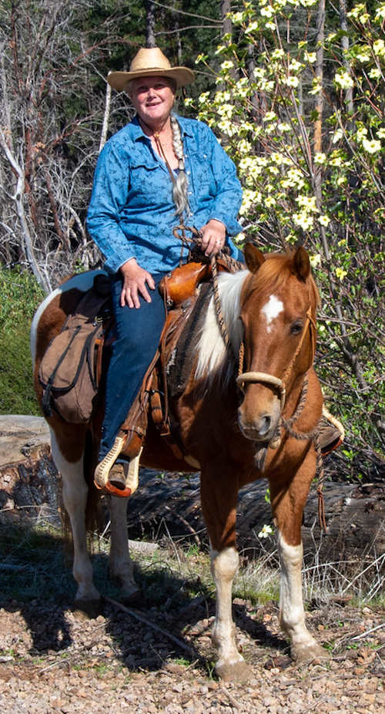
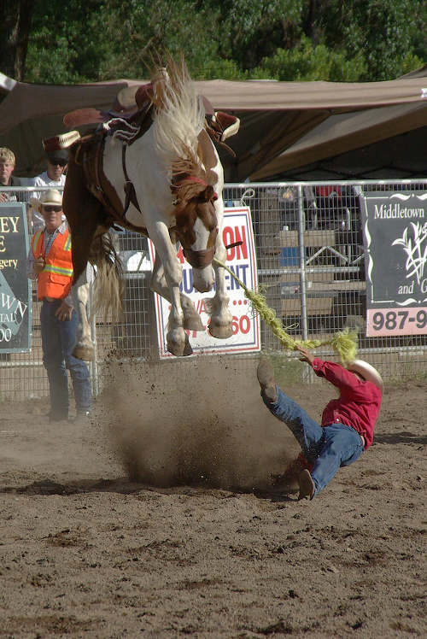
Nona Perez on Erin (aka Rain to her grandkids from the movie Spirit). Courtesy photo.
MIDDLETOWN, Calif. — This weekend’s Middletown Days will honor a longtime resident, photographer and horse enthusiast.
This year’s Middletown Days grand marshal is local photographer Nona Perez. Perez has a long history with Middletown and Middletown Days in particular.
Perez will head up this year’s Middletown Days Parade at 10 a.m. Saturday, June 18.
Perez was born in Middletown to Arval and Nadyne Edwards. Deanie Hardester was her first baby sitter before Perez, her older brother Anthony, and her parents moved to their new home on Mt. Saint Helena and she started school in Calistoga.
Her mother would paint, sculpt, and sketch. Nona did not possess those talents, but found that photography was a way for her to also “freeze the moment and capture it.”
Action shot by Nona Perez: Bronc rider is Guy Petta in the Middletown Days 2011 Ranch Rodeo.
She got her first camera from her dad at age 11 and she’s always packed a camera ever since. Her dad had an old Agfa camera that he brought back from Germany in 1950. It had a bellow that popped out and was “100% manual.” She had to set the distance, focus, aperture, shutter speed, and also had to remember to advance the film. Otherwise, she would get a double exposure. It was quite challenging to use and taught her a lot.
When she first got her camera she started taking photos of dogs, cats, horses, and people. She always enjoyed taking photos to preserve memories and recalls that when she was younger, the family tragically lost some family members and didn’t have a lot of photos of them. That episode and what photos mean to people always stayed with her. “Pictures are about memories. That’s why we take them. There is so much more there when you look back at the photo.”
When she was 13, Jim and Donna Kinyon helped her find and train her first horse, a 2 1/2 year-old paint filly named Patches. It was at this time that she met the Weatherwax family, and Rudy and Barbara Yudnich and their family, and formed friendships with daughters Carol, Karen and Sherry.
She started coming to gymkhanas in Middletown. Her first horse show was a halter class during Middletown Days 1970, and she didn't quite know what to do. She also says that she didn’t really like being the one showing as it was not in her comfort zone.
First prize that year was a breeding to Hill Comstock's Quarter Horse stud, Expensive Star. She didn’t win, but years later, she did have Patches bred to Expensive Star and got a colt her dad named Troupe.
It was after she got Patches that she learned that her father had grown up with work horses and had always wanted a riding pony. She says that she had great mentors in horsemanship and her father’s gentle nature influenced her approach to training.
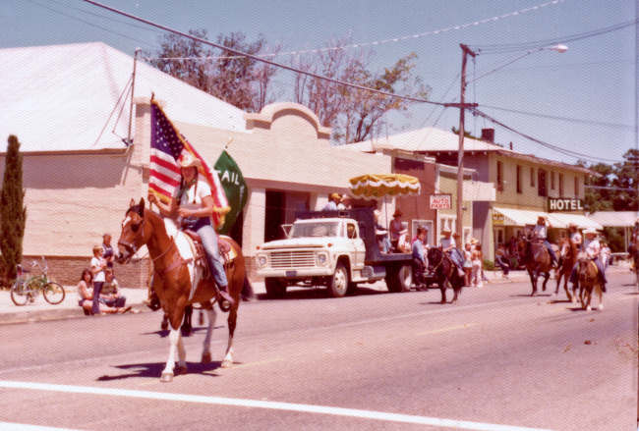Nona Perez on Patches during the Middletown Days Parade in 1976 as part of the Tail Hold Riders. Courtesy photo.
Those early gymkhanas she attended were announced by Bob Donley, “who always made us kids feel like we were doing a great job. He and his wife Pat have been a great influence in my life.” She also has fond memories of the Stimpsons, the Comstocks, and John Emerson. She had never felt like she fit in down in Calistoga and says that she “found her community in Middletown.”
When the family got a second horse, “it fulfilled my dad's lifelong dream of having a ‘riding pony’ and my parents took turns riding with me. My dad began riding in the gymkhanas after a dare from a friend. Wonderful memories!”
She also joined the Pope Valley Ropers and Riders and participated in their gymkhanas, as well. Her favorite event was pole bending.
In 1972, her love of all animals prompted her to begin working for veterinarian Glenn Baker in St. Helena. She was his first employee and worked for him for many years. When he got cattle she helped work them alongside his wife Karen.
When she was 18 or so she helped form a kids horse club with Bob Donley and Pam Wilson called the Tail Hold Riders. The club was formed to do the drill team, regular gymkhanas, and trail rides.
Some of the members included Kathy Dennis, Barbie and Vicky Poni, Joy Donley, Laura and Celena Menzio, Lisa Comstock, Keri and Wendy Johnson, Kat Thomas, Cheryl Evans, and “Greggy” Evans. Perez recalls that they all used to go on the most amazing trail rides at Guenoc, the Comstock Ranch, and at Diamond D Ranch.
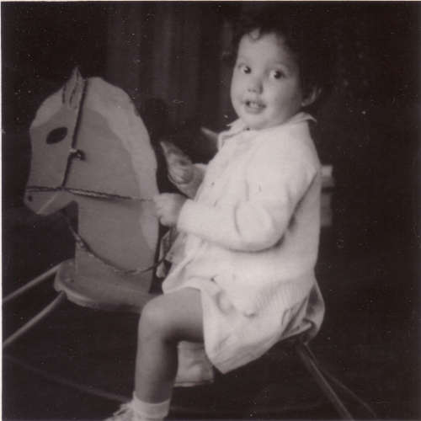Nona Perez's first horse. Courtesy photo.
Some years later, after the birth of her first child, she got an SLR with a zoom lens that gave her much more flexibility in her photography. Then, when her kids got involved with horses, she found that taking photos and capturing memories gave her something to do other than just sit around. Both of her daughters showed horses and all of her kids participated in the Middletown Days Parade and 4H where she served as a community leader.
That morphed into Perez shooting a few weddings, sporting events and even helping another local photographer, Craig Eve. Middletown Central Park hired her to record Middletown Days for many years since she was always there with her camera, anyway.
She says that while she enjoys photography it’s never been a full time livelihood for her. She spent her time homeschooling her kids, taking them to various events, and helping her husband, Elias Perez, with his construction business. They met when he was her neighbor “two miles down the road” when he used to help her dad fix fences and haul hay.
She still likes being invisible, behind the camera. But, she spends her time these days focusing on her other passions, training colts and taming horses that have never been handled. She especially enjoys teaching her grandkids to ride. She also spends a fair amount of time sewing. In fact, her grandkids will be wearing some items she has sewn for the parade.
Something that she's always loved about Middletown is the warm inviting atmosphere and the community involvement. Her favorite part of Middletown Days is “getting together with people you don’t see all the time.” It’s one of the few gatherings that she really enjoys. And, even though she’s not fond of the spotlight, she’s happy to be in the parade so long as her family is by her side.
