**63rd Middletown Days Parade Pioneers**

**The Weatherwax Family: Guardians of Community Spirit in Middletown**

In the annals of Middletown’s history, one of the names that stands out as a beacon of community spirit and generosity: the Weatherwax family. For decades, this remarkable family has left an indelible mark on the town, shaping its landscape and fostering a sense of togetherness that defines the very essence of community.

At the helm of this remarkable family were Bob Sr. and Gerry Weatherwax, the

monarchs whose warmth and hospitality knew no bounds. Bob and Gerry Weatherwax moved to the area in 1955 along with Bob’s mom, sister and two brothers. They moved from La Puente in southern California. Bob and Gerry dreamed of living in a small rural community and moving to this area was a dream come true. They welcomed everyone

with open arms, embodying the spirit of community.

Bob and Gerry have 4 children and 2 adopted children. Linda, Bob jr, Susie, Bill, Ted and Jeff. Their three children who still live in the area, Bobby Weatherwax and his wife, Linda, Susie Knowles and her husband, Tom, and Linda Diehl-Darns and her husband, Tom and the three children that live out of the area, Bill Weatherwax and his wife Kathy, Jeff Stopper and Ted Stopper have carried on their parent’s; legacy with pride, continuing to uphold the family traditions that have defined them, as well as volunteering to support community.

Among Bob and Gerry’s many contributions, the Weatherwax family initiated and hosted the Middletown Unified School District Teacher BBQs before the start of each school year. This annual event served as a gesture of appreciation and support for the teachers of Middletown, fostering a sense of camaraderie and unity within the educational community.

Long before Sober Grad became a widespread practice, Bob and Gerry Weatherwax

took it upon themselves to ensure the safety of Middletown’s graduating students. They

hosted their own Sober Grad celebrations, which included a live band at their ranch in Snell Valley, providing a safe and alcohol-free environment for graduating students and their friends.

Their foresight and dedication undoubtedly saved countless lives and set a precedent for responsible graduation celebrations in the community.

Additionally, Bob and Gerry’s influence extended to the realm of sports and

extracurricular activities through the establishment of the Sports Boosters. Their

support and advocacy helped provide essential resources for Middletown’s student

athletes, fostering a culture of excellence and achievement within the local sports

community.

At the heart of their legacy lies their instrumental role in the development of

Middletown Central Park. The land was donated to the community for a park by ancestors of the Hardester family. Back in the 1960s, when the town was in need of a communal space for gatherings and recreation, the Weatherwax family stepped forward along with other community members. Their contributions, both in terms of time and money, were pivotal in transforming a mere idea into a vibrant reality.

Bob & Gerry’s involvement in the development of Middletown Central Park continues today. They rolled up their sleeves and became deeply engaged in the process, investing their time and energy to ensure that every aspect of the park reflected the needs and desires of the community. From the creation of the arena, stage, and dance floor to the establishment of the original senior center and BBQ area, as well as their support of the Middletown Days Queen Contest. Their fingerprints can be found in every corner of the Park.

Bob & Gerry’s commitment to community service was exemplified through their instrumental role initially establishing the Middletown Lions and Lioness Clubs as charter members. Not only did they contribute financially to the clubs’ founding, but they also donated their time and resources to ensure its success. Bob Weatherwax jr. Susie Knowles and Tom Knowles and Linda Diehl-Darms continue volunteering and supporting the Lions Club and community.

In addition to their involvement with Middletown Central Park Association and the Lions and Lioness Clubs, the Weatherwax family has played integral roles in other community service organizations, including the Middletown Merchants Association and the Middletown Luncheon Club.

The enduring legacy of the Weatherwax family in Middletown is not just a tale of

philanthropy and community service; it’s a story of multigenerational commitment and

unwavering dedication to the betterment of their hometown. With each passing

generation, their impact has only grown stronger, leaving an indelible mark on the

fabric of Middletown’s identity. Rooted deeply in the soil of Middletown, the Weatherwax family has seen five generations here, each contributing in their own unique way to the town’s growth and prosperity.

Their dedication to Middletown’s development is evident in every aspect of their lives.

For the Weatherwax family, giving back to their community is not just a choice; it is a

calling. Family, friends, and the town itself are all integral parts of their lives, and they

work tirelessly to ensure that Middletown continues to thrive.

As the Weatherwax family continues to write their chapter in Middletown’s history, their

legacy serves as a beacon of inspiration for future generations. Their unwavering

commitment to family, friends, community and service reminds us all of the power of

selflessness and compassion in shaping a brighter tomorrow.

Their story serves as a powerful reminder of the profound impact that individuals and families can have when they come together for the greater good. In the hearts and minds of the people of our community, the Weatherwax family will forever hold a special place as true guardians of community spirit and unity.

Edith Weatherwax Bob’s Mom

Bob & Gerry Weatherwax

Daughter, Linda Diehl-Darms and Husband, Tom –

Son, Jakob Diehl and wife, Stephanie

Children Reylin and Giovanni

Son, Bob Weatherwax jr and Wife, Linda –

Son, Robby Weatherwax –

Children, Ruby, Kaycee and Karlee

Daughter, Brianne Weatherwax and Buck Menzio

Children, Kayden & Cooper

Son, Sammy Weatherwax

Daughter, Susie Knowles and Husband, Tom

Son, Charlie Green and Wife, Dena

Children – CJ, Emmie, Sue, Kenny

Daughter, Geri Costlow and Husband, Brandon

Children – Brandon jr., Brody, Blake

Daughter, Caity Burgess and Husband, Jake

Children – Elliott, Kane, Rocco, Navy

Son, Bill Weatherwax and Wife, Kathy

Daughter, Ginnie Marie Guidotti and Husband, Jeremy

Children – Ella and Warner

Daughter, Becki Bigiogni and Husband, Brian

Children – Olivia and Bella

Daughter, Heidi Weatherwax and Derek Gurley

Children – Carter & Logan

Daughter, WyndiJo

Son, Jeff Stopper

Son, Stephen Stopper

Daughter, Christine Bray and Husband Brandon

Children – Grayson and Wyatt

Son, Ted Stopper

Daughter, Amber Lambert and Husband Keenan

Children – Roman and Troy

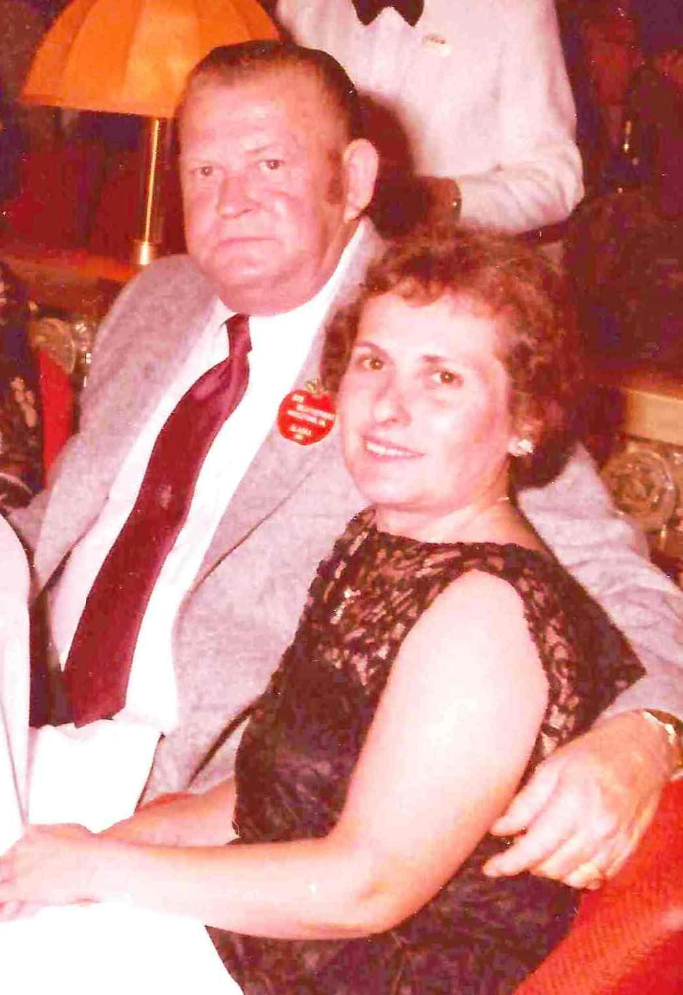

Bob & Gerry

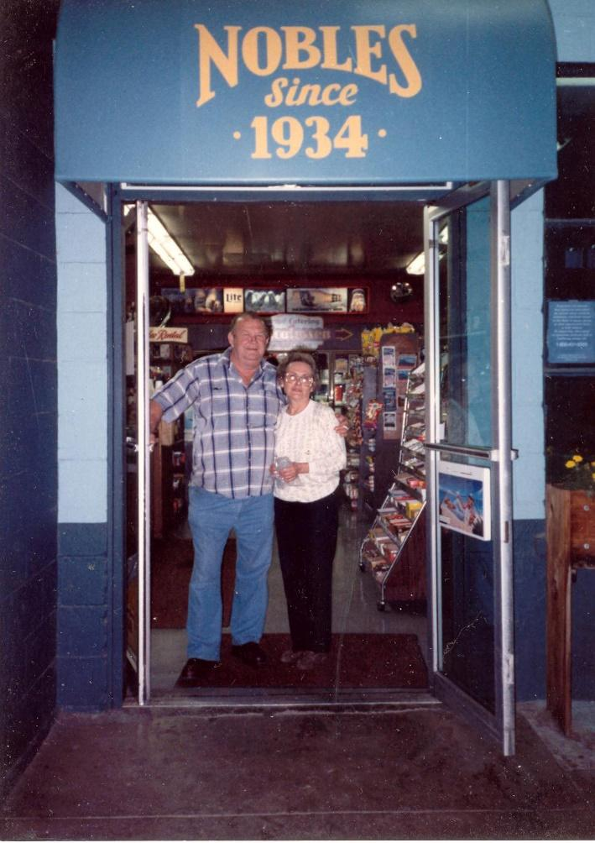

Bob & Gerry

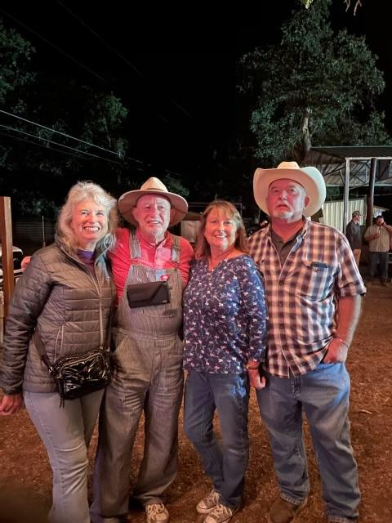

Linda – Bill – Susie - Bob

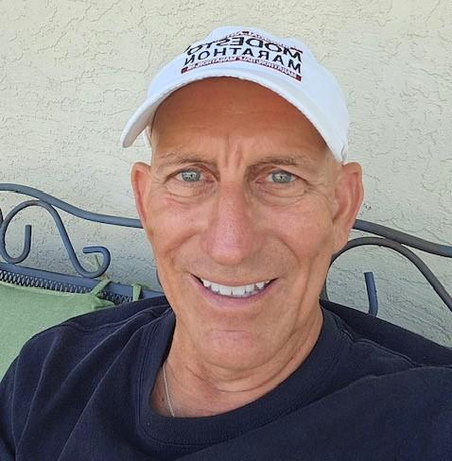

Jeff Stopper

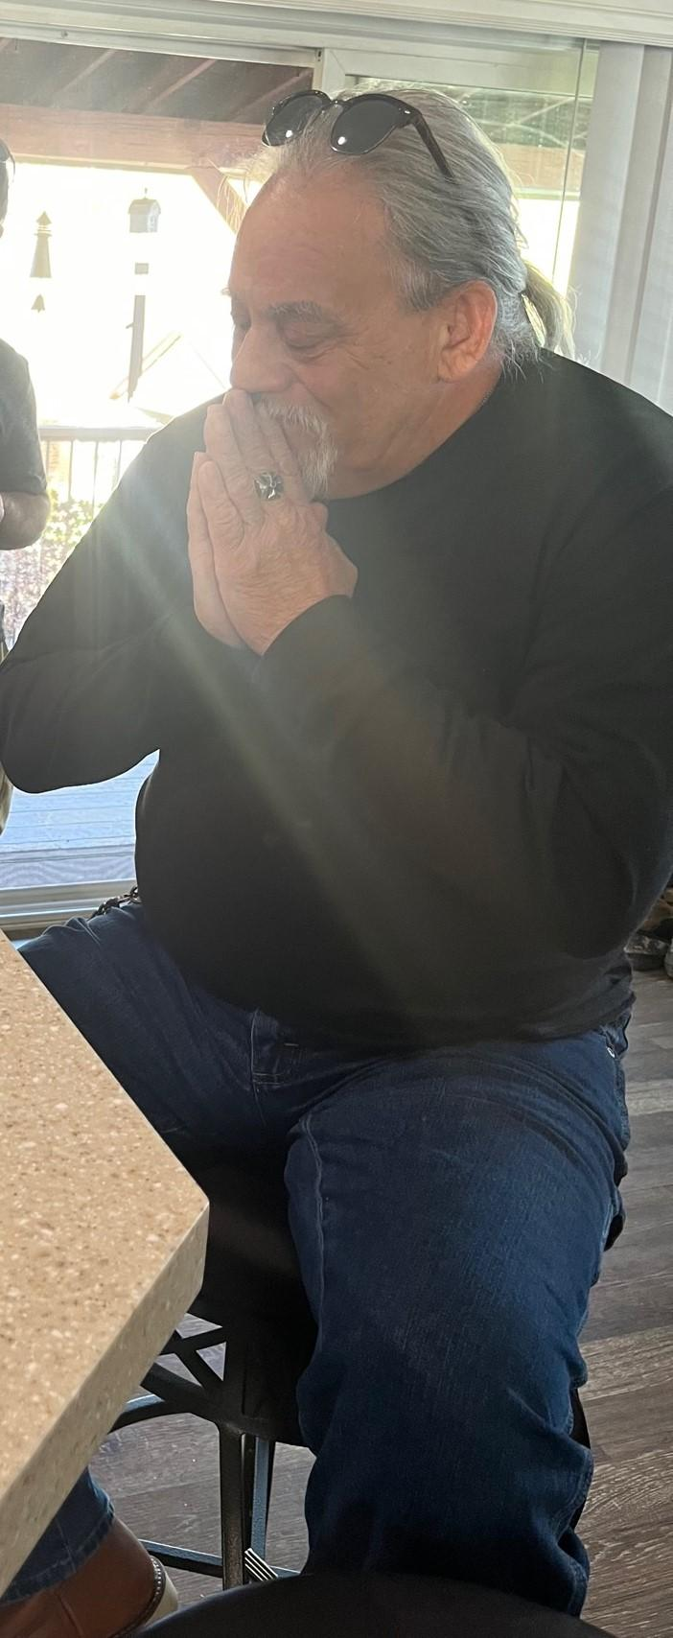

Ted Stopper