**Chanele Hellwege Named Grand Marshal of Middletown Days**

**Middletown, CA** — In a heartwarming announcement, Chanele Hellwege has been named the Grand Marshal for the 2024 Middletown Days parade. Known for her unwavering dedication to family and community, Chanele epitomizes the spirit of Middletown, making her a fitting choice for this honor.

Chanele is a young mother of six children and the life partner of Dan Knudsen. The couple share their dream home on a stunning 56-acre ranch in Anderson Springs, lovingly built by Dan. Their bustling household is filled with joy, hard work, and the satisfaction of creating a nurturing environment for their children.

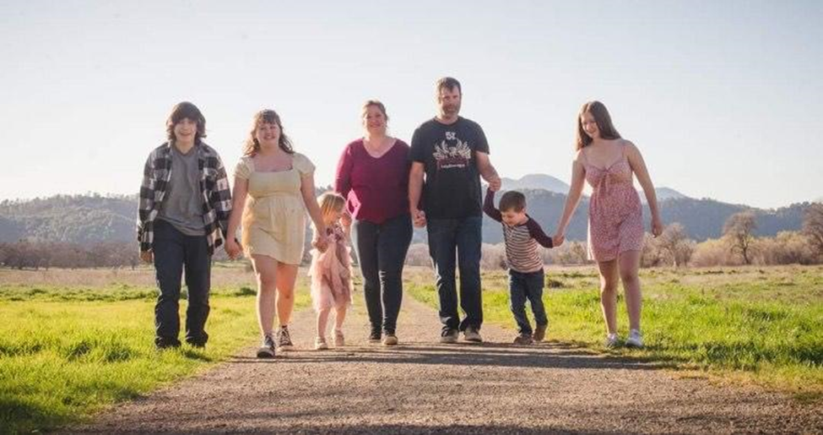

The Hellwege-Knudsen family

Over the past five years, Chanele has transformed a small shipping venture into a thriving business, Middletown Mail & More. Catering to the diverse needs of Middletown and Lake County residents, her business has become an essential local hub. Chanele’s entrepreneurial journey began under the mentorship of Margaret Greenley, whose guidance helped her turn a simple idea into a successful enterprise. Chanele saw a need and filled it.

Chanele is deeply embedded in the community fabric, actively participating in the Middletown Area Merchants Association (MAMA). This group is instrumental in organizing cherished local events such as Christmas in Middletown, Movie in the Park, and Career Day at the high school. Chanele's commitment to these activities underscores her belief in community involvement. "If everyone does one thing for our community, it will continue to be a better place," she says, emphasizing her philosophy of collective effort.

Her dedication extends to local education initiatives as well. Chanele and Dan played pivotal roles in starting the school garden at Minnie Cannon Elementary and were instrumental in building the school’s playground. These contributions reflect their deep-seated belief in improving community resources and fostering a nurturing environment for future generations.

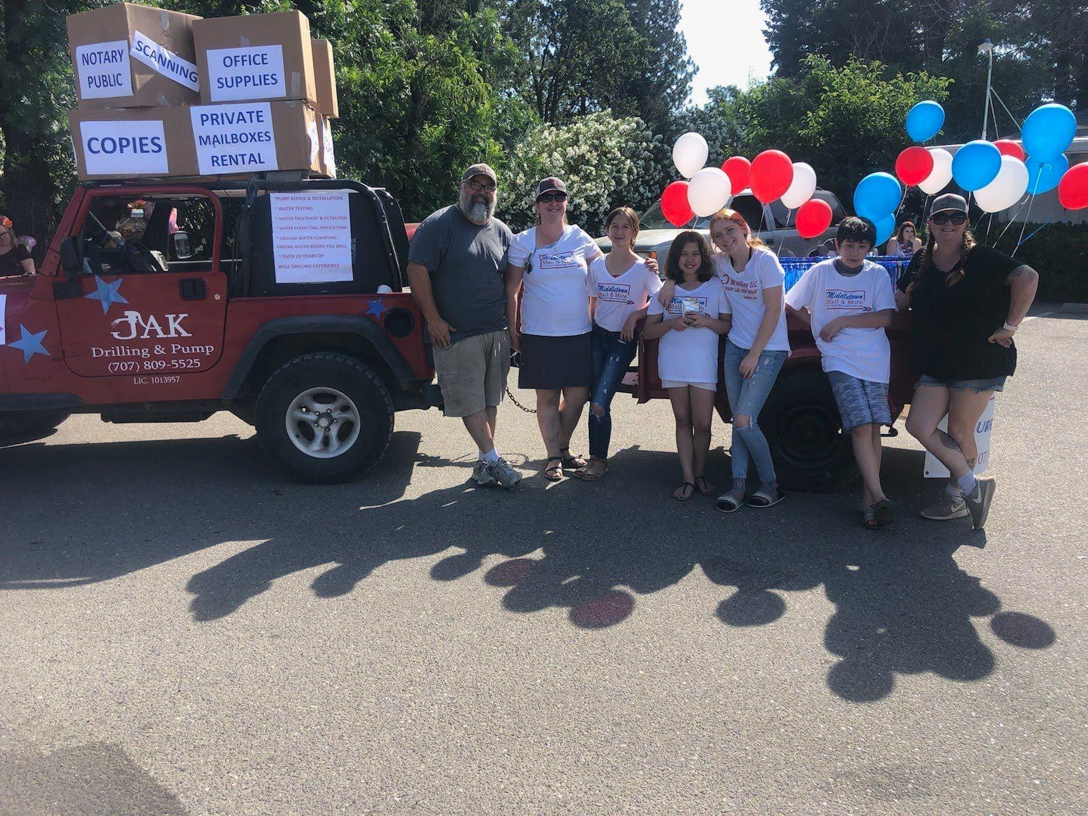

Middletown Days Parade with family members

Raised in a family with a strong work ethic, Chanele's roots in Lake County run deep. She is one of five siblings, all of whom were brought up in the well drilling business—a family tradition that her brother, Khrom Hellwege of JAK, continues today. Chanele, a graduate of Kelseyville High School, has always valued the importance of hard work and community spirit, principles instilled in her from a young age.

As Grand Marshal, Chanele will lead the Middletown Days parade, an event that brings together residents and visitors to celebrate local heritage and community spirit. Her selection as Grand Marshal is a testament to her impactful contributions and the admiration she has garnered from her fellow residents.

"Chanele Hellwege represents the heart and soul of Middletown," said a spokesperson for the Middletown Days committee. "Her dedication to her family, her business, and her community is truly inspiring. We are thrilled to honor her as our Grand Marshal."

Chanele's guiding philosophy, "You get more out of life by saying 'Yes'," continues to inspire those around her. Her story is a powerful reminder of what can be achieved with dedication, hard work, and a commitment to community. As she leads the parade, Chanele stands as a beacon of the values that make Middletown a wonderful place to live and thrive.